**Experiment Number: 7**

**Title: Bubble sort**

**Problem Statement:** Write a C++ program to arrange the given set of numbers in ascending order using Bubble sort.

**Algorithm:**

* Starting with the first element(index = 0), compare the current element with the next element of the array.
* If the current element is greater than the next element of the array, swap them.
* If the current element is less than the next element, move to the next element. Repeat Step 1.

**Code:**

#include<iostream>

using namespace std;

int main()

{

int array[50], n, i, j, k, temp;

cout<<"Enter the size of array: ";

cin>>n;

cout<<"Enter the array elements to be sorted:";

//To read the array

for(i=0;i<n;++i)

cin>>array[i];

cout<<"Array before sorting :";

for(i=0;i<n;++i)

cout<<" "<<array[i];

for(i=1;i<n;++i) // i keeps track of the no. of passes

{

{

for(j=0;j<(n-i);++j)

if(array[j]>array[j+1])

{

temp=array[j];

array[j]=array[j+1];

array[j+1]=temp;

}

}

//To print the array elements after every pass

cout<<"\n\n Array after Pass "<<i<<":" ;

for(k=0;k<n;++k)

cout<<" "<<array[k];

}

cout<<"\n\nArray after bubble sort:";

for(i=0;i<n;++i)

cout<<" "<<array[i];

return 0;

}

**Output:**

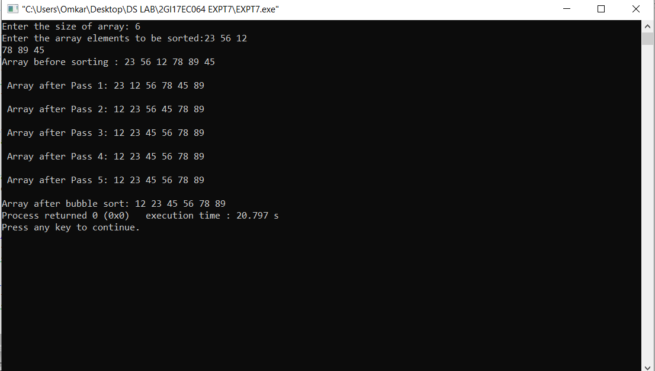

**ANALYSIS(LIMITATIONS):**

The main disadvantage of the bubble sort method is the time it requires. With a running time of O(n^2), it is highly inefficient for large data sets.